If you want to be a genius follow these intelligence tasks .to be word smart you need to read and focus in your english class and leave time to read .to be people smart you need to socialize and go out with friends to understand how to be a good friend to them. To be body smart you need to get outside and do exercise and do sport and engage in PE lessons.to be nature you need to read books about tree wildlife and and get out in a forrest and look around and note species.to be number you need to revise in maths and focus in lessons .to be self smart learn about yourself and let yourself know what you want. To be picture smart you need to go to a gallery and study techniques on art work. To be music smart listen to music and notice different notes and keys in the music piece

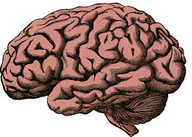

BRAIN